Didn’t understand about the 1 K it shows ongoing, completed services, pending

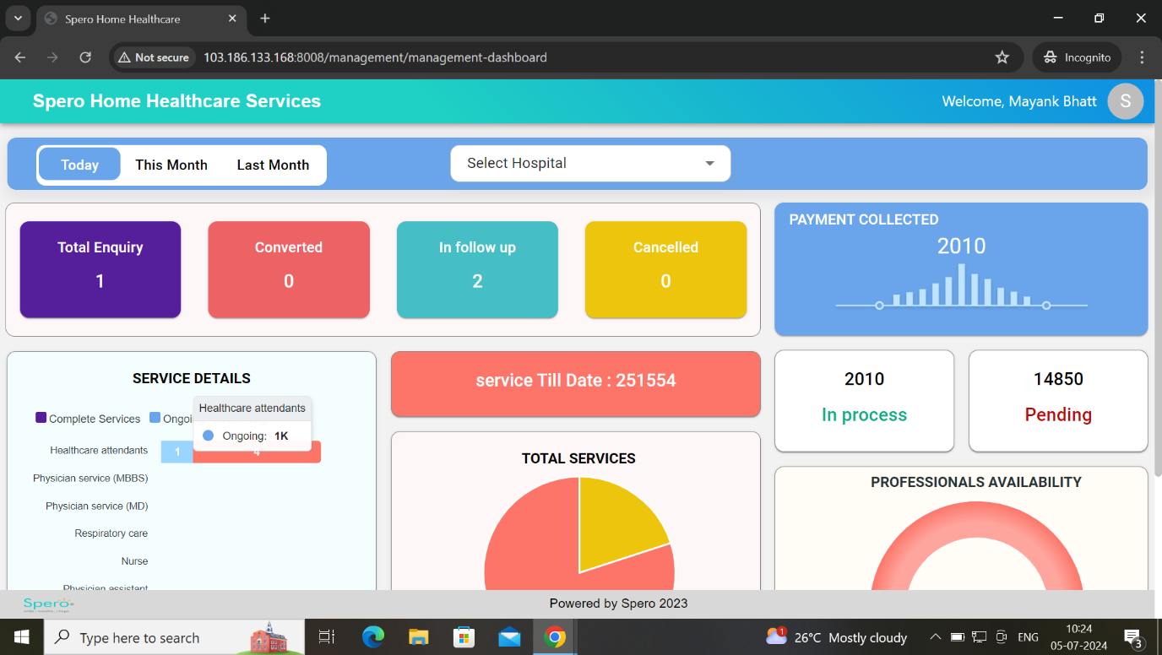

Correct it “professional name”

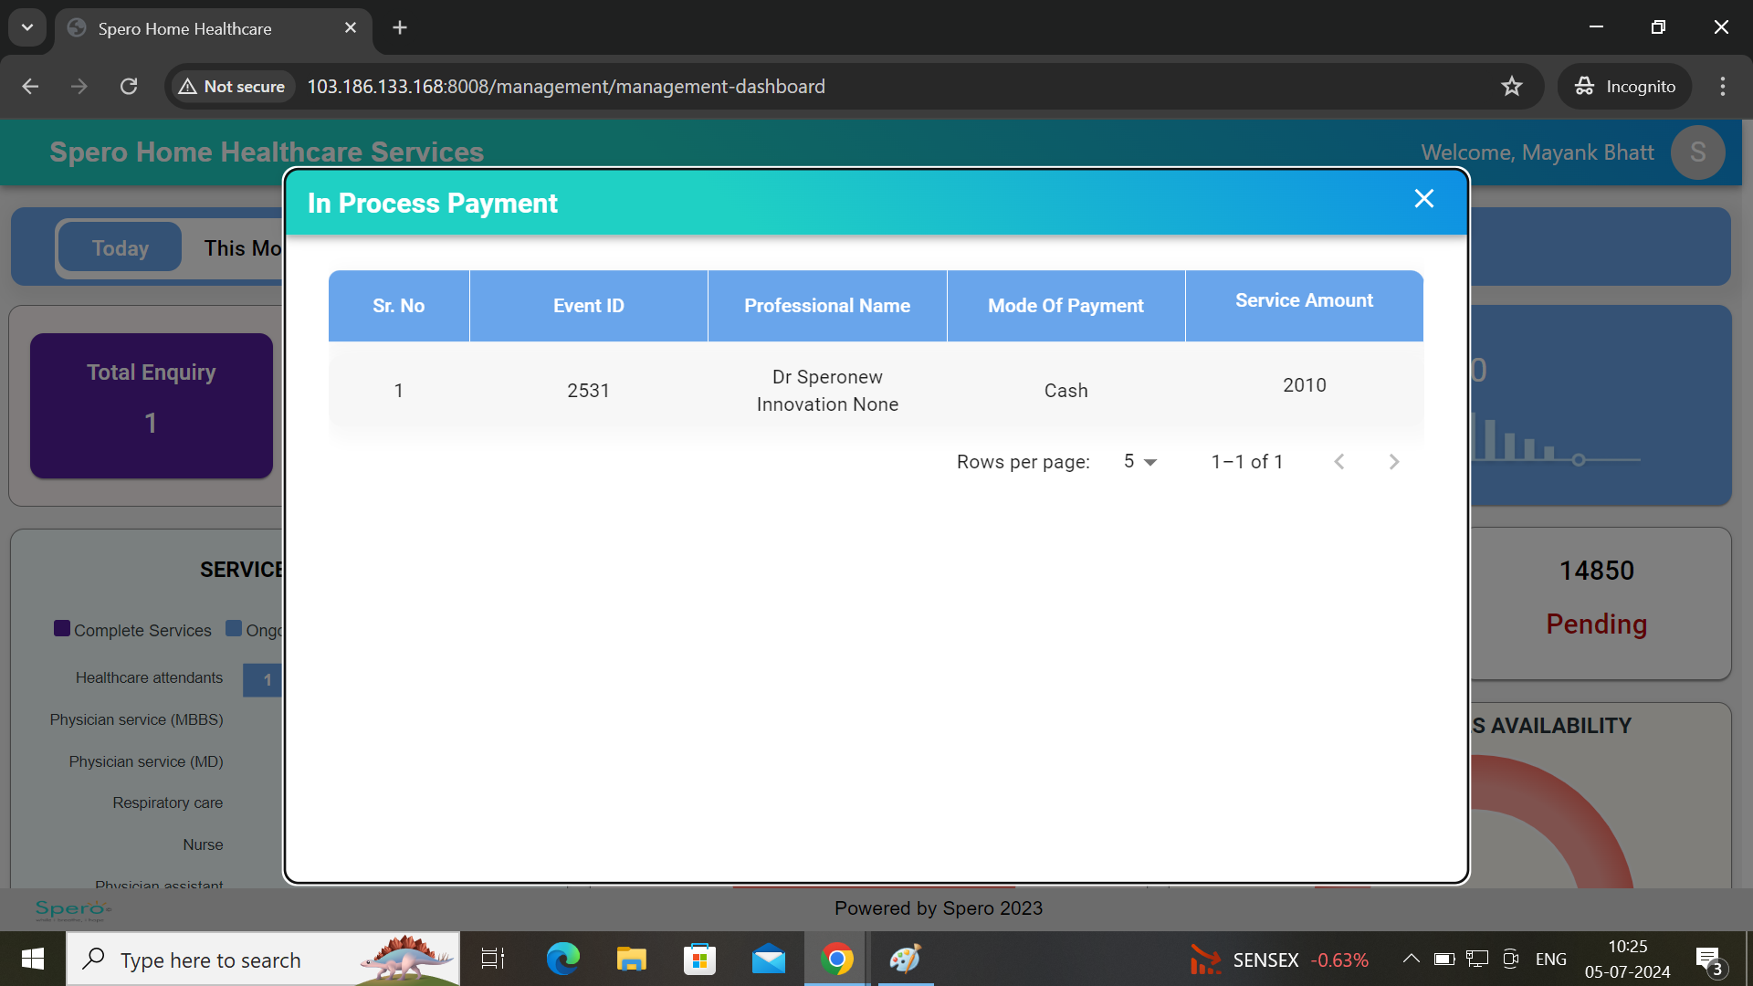

Its Completed service

