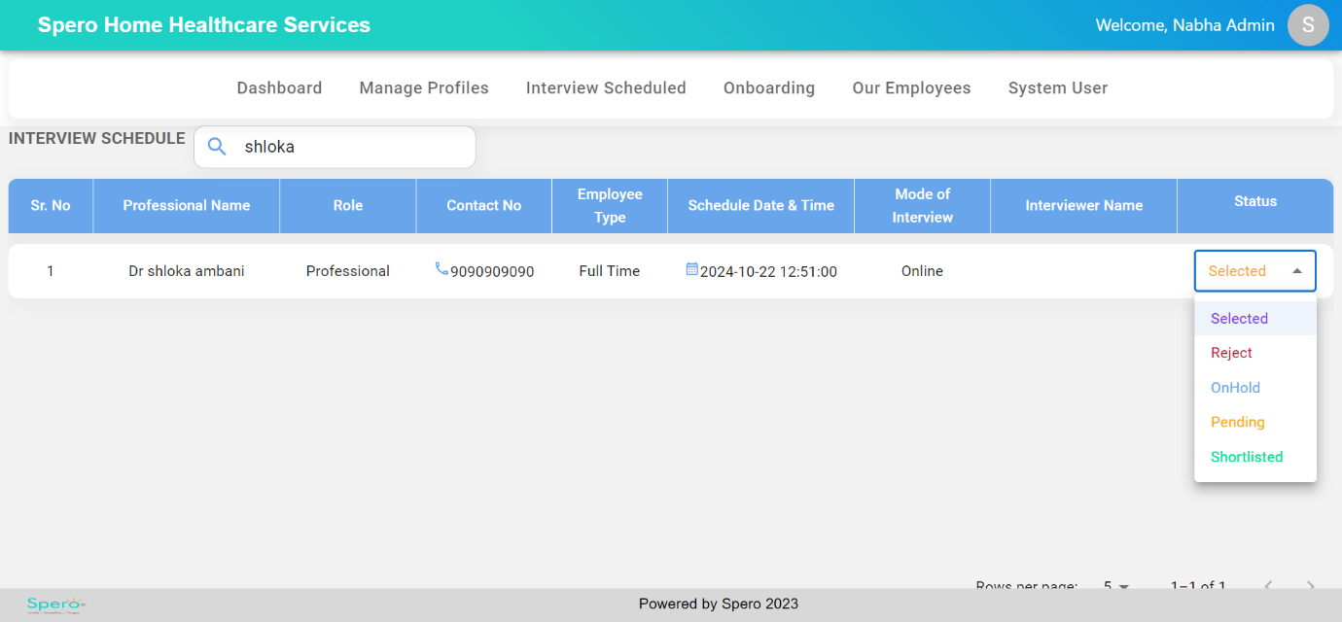

confirm about the status shortlist, rejected